Create daemon.sh 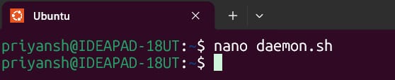
Daemon.sh – script 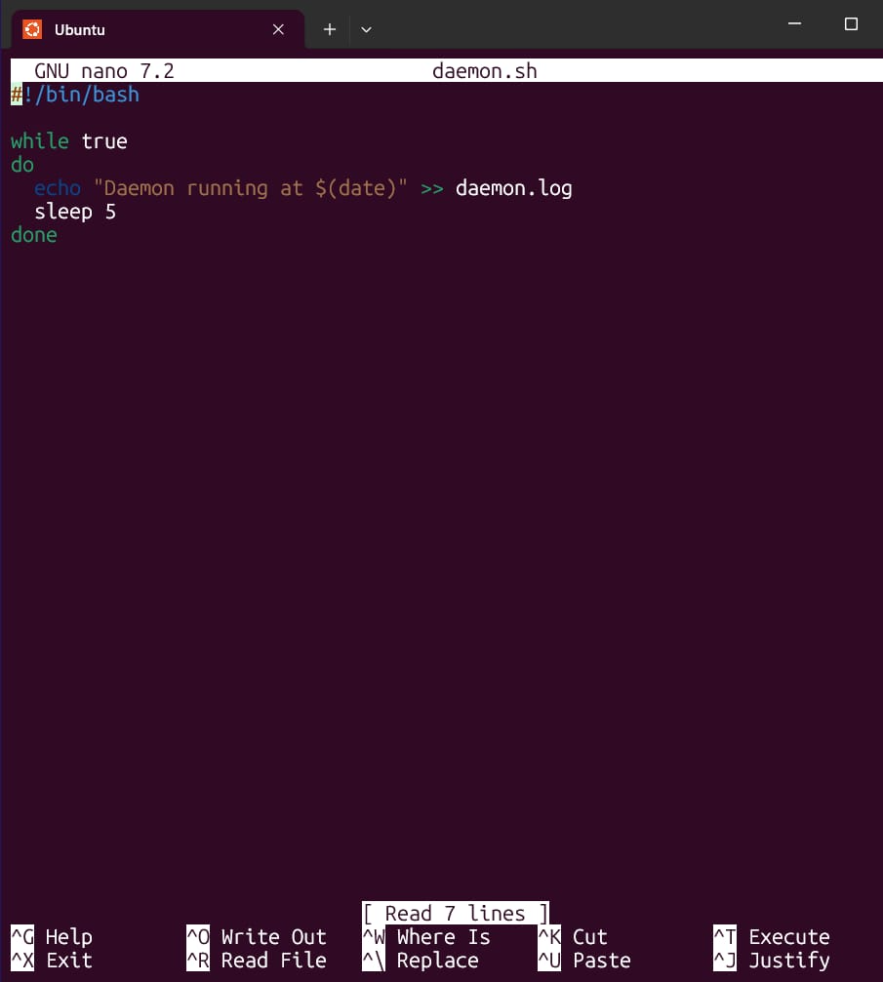
Ctrl + S – save it & Ctrl + X – exit
Make script executable
Run the script in Background - ./daemon.sh &
Check on the process - ps aux | grep daemon.sh 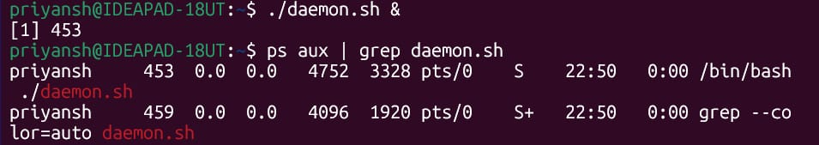
Kill the process using PID 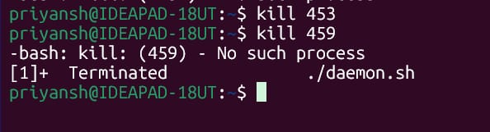
Create service file -
Type the password and you'll enter script edit mode 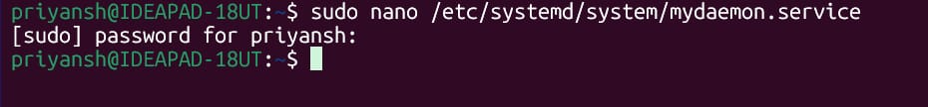
mydaemon.sh – script 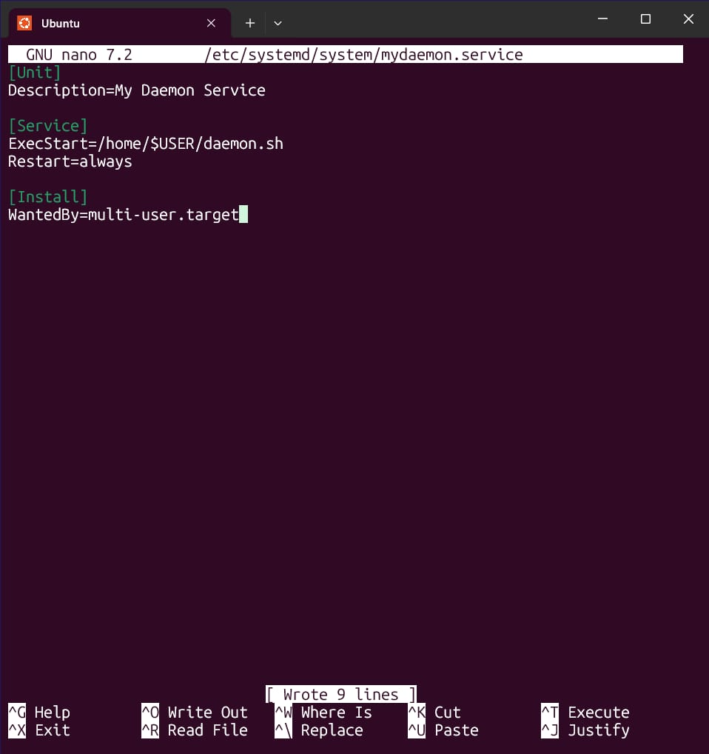
Enable and Start the services 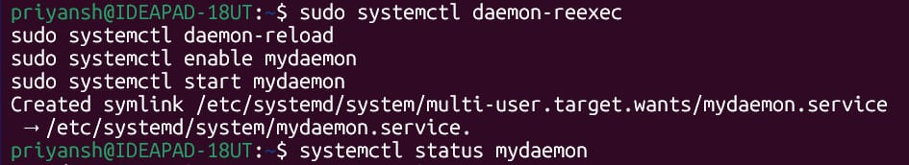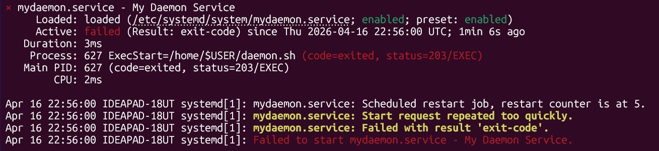
Create CronTab 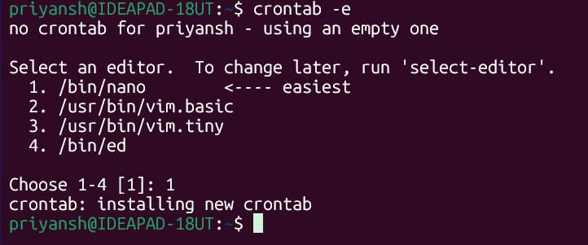
Crontab – script
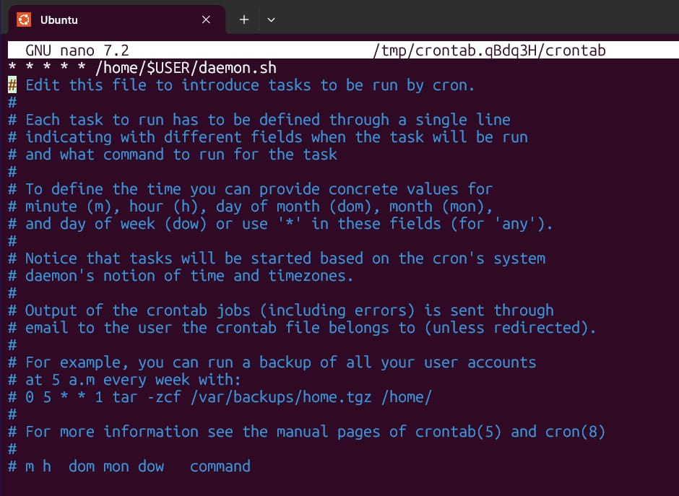
Crontab l- to check 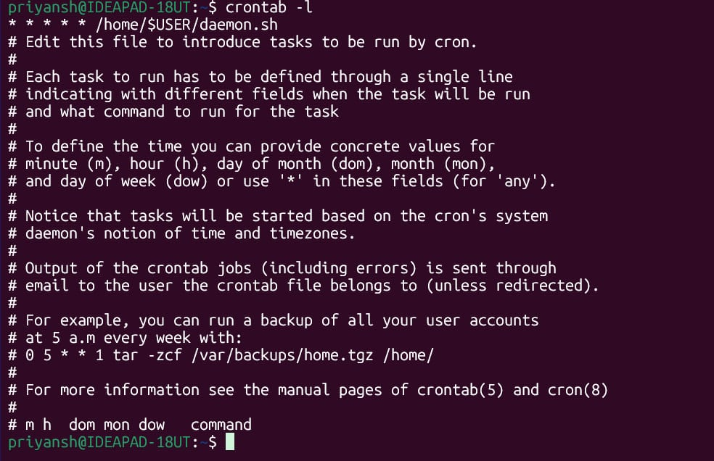
To Install Fuse -
sudo apt update
sudo apt install fuse3 python3-pip -y
pip3 install fusepy
(It can take some time to install Fuse)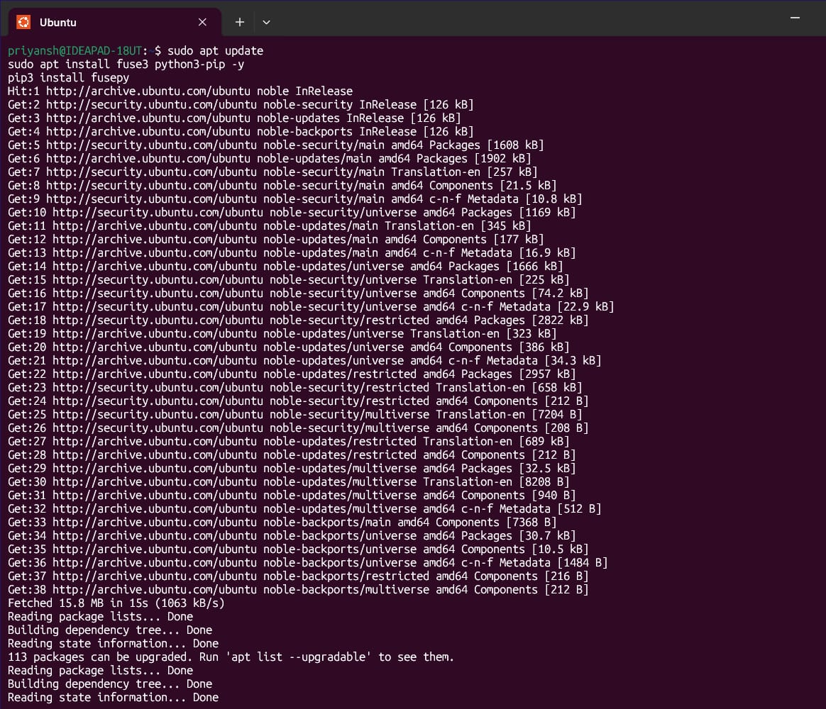
Create fuse_fs.py 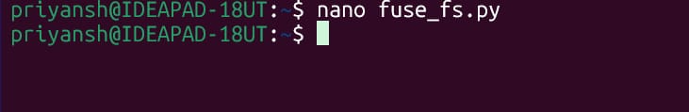
Fuse_fs.py - script
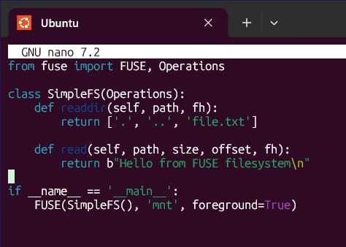
Create mount directory and then run the FUSE Filesystem 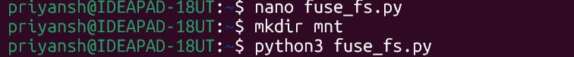
The Terminal will get busy for this so open a fresh one and then type these to get the output -
ls mnt
cat mnt/file.txt - "Hello from FUSE Filesystem"
And then unmount FUSE - fusermount -u mnt 